Write a sentence for the picture below. Use the indicated sentence starter.

Adjectives/ Adverbs
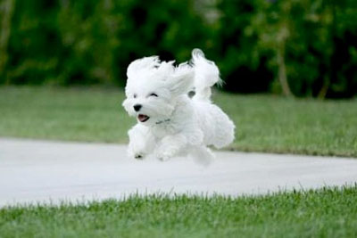

Appositive
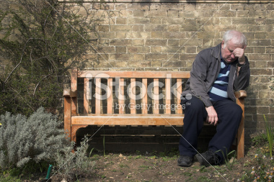

Simile/ Metaphor
